VR Strike Dojo
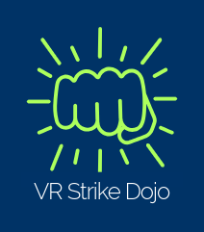
Virtual Reality Brochure
  - Samuel Gillary N1000331

INtroduction
VR Strike Dojo is an immersive virtual reality game that utilises Meta XR plugins for real-time, controller-free hand tracking designed for rehabilitation of the upper limbs. The player will have 3 minutes to break as many incoming projectiles as possible. This includes boulders, for which require a closed-fist punch to shatter, and logs, which require an open-palm karate chop to cut in half. For each object successfully destroyed, the player receives a point, encouraging motivation. The overall aim is to improve the user’s hand-eye coordination, as well as encouraging repetition of upper limb mobility.

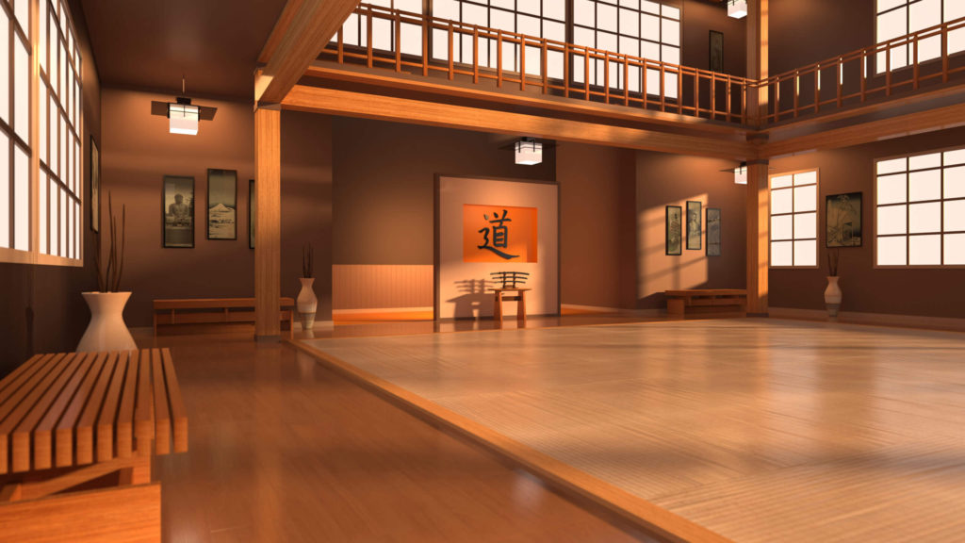

(Source: https://we-languages.com/is-dojo-related-only-to-martial-arts/)

BACKGROUnd  The demand for innovative rehabilitative technologies has never been more critical. The efficacy of traditional clinical exercises is often undermined by low patient adherence, primarily driven by diminished self-efficacy, limiting personal beliefs, and physical pain (Argent, Daly and Caulfield, 2018). The foundation of effective neurological and muscular recovery, especially for upper-limb impairments, relies on experience-dependent neuroplasticity. This biological process involves executing function movements hundreds of times to successfully form new neural pathways (Kleim and Jones, 2008). However, traditional physiotherapy regimes often fail to reach this volume. There is a stark discrepancy between the amount of required repetition to induce neuroplasticity and the minimal repetitions that are actually carried out in standard rehabilitative care (Lang et al., 2009). Without immediate cognitive feedback or external motivation, therapeutic fatigue may occur, stalling the rehabilitative process.  To combat these barriers, Virtual Reality (VR) directly addresses this issue. VR provides a platform to be immersed in an engaging digital environment, while simultaneously facilitating rehabilitative therapy by providing that critical immediate feedback and motivation. Furthermore, there is a correlation between the visuomotor feedback and biological recovery. One investigation discovered that the customisable and sensory-driven nature of VR exploits the central nervous system’s potential for functional reorganisation (Cheung et al., 2014). |  |  | background cont’d  By delivering targeted, task-specific multimodal stimulation, the virtual environment directly modulates the primary motor cortex, increasing the likelihood of transferability of skills acquired in VR to real-world functional independence.  Building upon this functional reorganisation capability, this project harnesses the customisability of virtual environments to apply advanced, patient-specific biomechanical therapies. Central to this approach is the use of Asynchronous Motor Training (AMT). In reality, true functional independence rarely relies on mirrored movements; rather, it requires the brain to coordinate independent, asymmetrical limb movements simultaneously (Waller and Whitall, 2008). This application utilises a system that determines which arm should be used at the point of spawning, while also having variable spawn intervals and speeds. Furthermore, the system alternates between distinct target types: boulders and logs, each of which requiring a biomechanically separate hand movement (punch for the boulder, and a karate chop for the wood). The implementation of this system aims to strengthen unilateral coordination, cognitive processing speed, and dynamic core stability. This is further supported by the use of real-time hand tracking, translating physical movements into direct virtual interactions.

caveats and benefits  With that being said, some caveats arise with this product:  - Firstly, this project would be considered clinically adjacent, and not an outright replacement for physical therapy. This application provides a safe and engaging environment where safe and trackable exercises can be practised at home.  - This application is better suited for a stationary boundary. The game is able to be played sitting or standing up, however it is recommended that the player remains stationary, in order to prevent any potential injury, nor exacerbate any preexisting symptoms such as compromised balance.  Contrarily, some benefits of the application include:  - By having some aspect of rehabilitation at home on a VR headset, you empower the patient to have some agency in their own rehabilitation and healing journey, in addition to potentially reducing their dependency on their caregiver.  - This application aims to provide a positive feedback loop with the point system that is focussed on consistency and effort as opposed to just reaction speed. This may prevent feelings of helplessness in the patient.  - No biometric data is kept within the application and hand positions are only tracked at runtime. |  |  | state of the market  Alternative VR-assisted rehabilitation products in the market are generally polarised between highly clinical, proprietary software and commercial entertainment. Clinical products, such as MindMaze (MindMaze, 2026), offer extremely accurate therapeutic tracking technology but often are prohibitively expensive, hardware-intensive, and restricted to clinical settings under professional supervision. Alternatively, rhythm and fitness games, such as Beat Saber (Beat Games, 2019), are a lot more accessible when it comes to home use and gamifying upper limb movement. However, they come with the disadvantage of requiring the use of physical controllers, which excludes players with compromised grip strength or dexterity, and their quick, reflex-heavy pacing can induce frustration or diminish motivation. Even with games that utilise hand tracking technologies, for instance Waltz of the Wizard (Aldin Dynamics, 2019), they are targeted to a more commercial audience, and their core functionality rarely accommodates users with limited dexterity.  This is where VR Strike Dojo sets itself apart. Utilising hand tracking removes the requirement for grip strength but also allows for more forgiving recognition of hand gestures to account for any limited dexterity within the player’s hands. The more forgiving gesture recognition within the application shifts the focus away from fine motor precision and towards gross motor recovery, allowing the player to break targets using various hand positions, like a fist or an open palm. Furthermore, it ensures that players are not unfairly penalised for incomplete finger closure or perfect hand positioning but provides positive reinforcement for detecting the intent of the movement instead.

game design  The core game loop involves a stationary player intercepting projectile targets, which are moving towards the player. The system spawns these obstacles at random intervals after the obstacle either flies past the player, or is broken by them. There are two current obstacles within the prototype: logs and boulders. Each obstacle has a message on top of it which denotes which arm the player should use to break the obstacle. The player then makes the appropriate hand movement for that target, and should it make contact with the target, it will break apart. For each obstacle destroyed in this way, a point will be awarded. After 3 minutes, the player will be able to see how many points they had successfully collected.  The dojo aesthetic fits the nature of the application due to the gestures often being associated with martial arts, and the use of the movements to break objects. To maintain an immersive environment, there is no bespoke 2D UI or controller inputs implemented. The game instead relies on diegetic UI attached to the 3D incoming obstacles, and a scoreboard in the environment, to convey important mechanical information. Moreover, removing the need for physical controllers needed a robust, custom interaction system facilitated entirely by real-time hand tracking and gesture recognition.  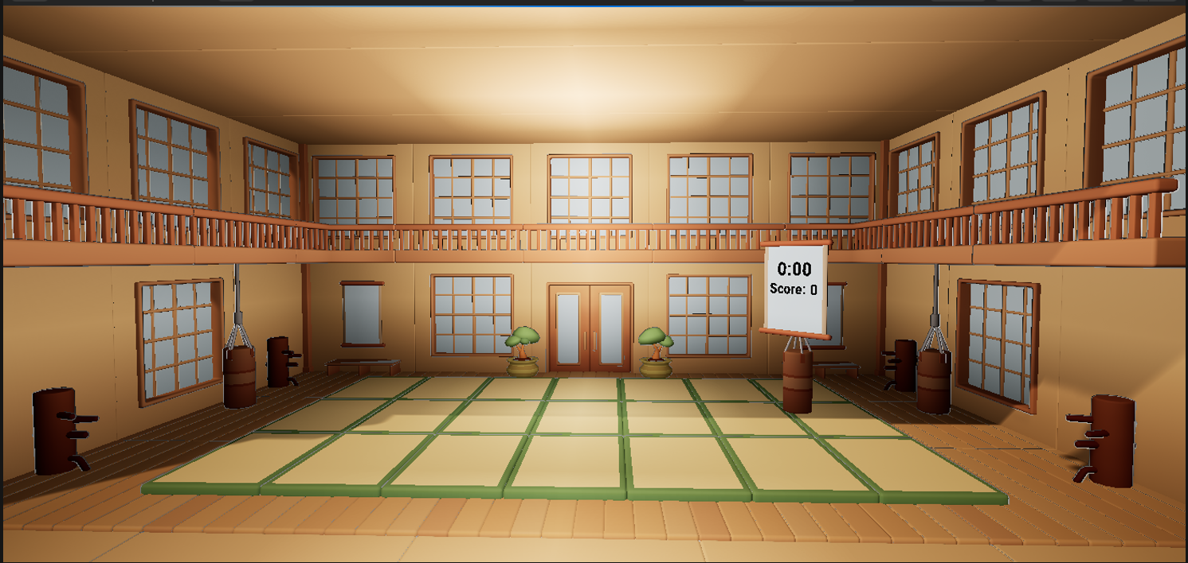 |  |  | future additions  In future versions of the application, sound would be added to add further immersion. Furthermore, a wider range of gestures and obstacles would be implemented. Some ideas include: a pinch gesture summons a dart, and the player throws the dart at a balloon; a swinging axe approaches the player, and they have to dodge the axe; a pushing motion to push some doors open. Bilateral training and synchronous hand movements would also be feature. Controller support would be considered, and there would be customisable settings altering the game in ways such as setting, obstacle speed, rate of obstacle spawning, a dropdown which determines which obstacles spawn, and a difficulty modifier.

The inputs
Using Unreal Engine and Meta XR plugin, two main hand gestures are used within the application are as following:

Punching the rock
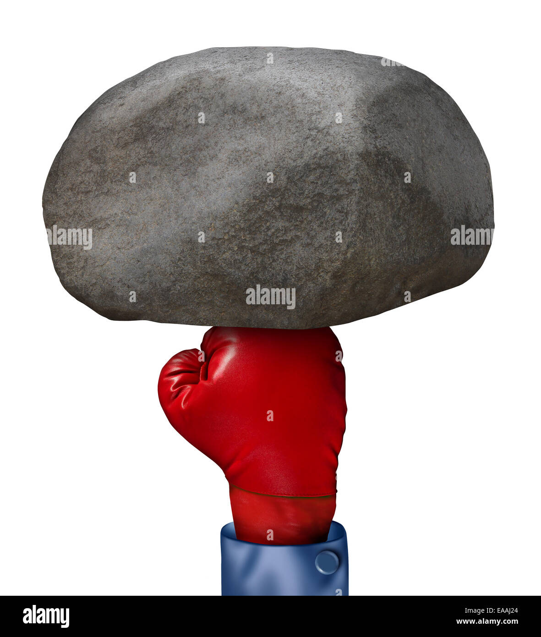 | A punch motion, which consists of an enclosed fist and a slight thrust forward. This is used for the boulder obstacle, which when contact is made with it, will explode.  (Image source: https://www.alamy.com/stock-photo-power-solution-business-concept-as-a-red-boxing-glove-punching-a-huge-75221724.html)

Slicing the log
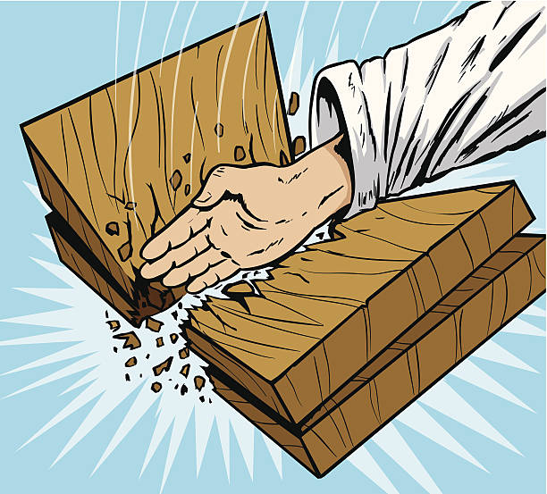 | A karate chop motion, which involves an open palm where the four fingers are outstretched and close together, and a downward motion. This is utilised for the log obstacle, which when contact is made, will split in half.  (Image source: https://www.istockphoto.com/vector/board-break-karate-style-gm468937693-34499442)

references  Argent, R., Daly, A. and Caulfield, B. (2018) ‘Patient Involvement With Home-Based Exercise Programs: Can Connected Health Interventions Influence Adherence?’, JMIR mHealth and uHealth, 6(3), p. e47. Available at: https://doi.org/10.2196/mhealth.8518.  Kleim, J.A. and Jones, T.A. (2008) ‘Principles of Experience-Dependent Neural Plasticity: Implications for Rehabilitation After Brain Damage’, Journal of Speech, Language, and Hearing Research, 51(1). Available at: https://doi.org/10.1044/1092-4388(2008/018).  Lang, C.E. et al. (2009) ‘Observation of Amounts of Movement Practice Provided During Stroke Rehabilitation’, Archives of Physical Medicine and Rehabilitation, 90(10), pp. 1692–1698. Available at: https://doi.org/10.1016/j.apmr.2009.04.005.  Cheung, K.L. et al. (2014) ‘Neuroplasticity and Virtual Reality’, in P.L. Weiss, E.A. Keshner, and M.F. Levin (eds) Virtual Reality for Physical and Motor Rehabilitation. New York, NY: Springer New York (Virtual Reality Technologies for Health and Clinical Applications), pp. 5–24. Available at: https://doi.org/10.1007/978-1-4939-0968-1_2.  Waller, S.M. and Whitall, J. (2008) ‘Bilateral arm training: Why and who benefits?’, NeuroRehabilitation. Edited by L. Sawaki, 23(1), pp. 29–41. Available at: https://doi.org/10.3233/NRE-2008-23104. |  |  | references cont’d  MindMaze (2026). MindMaze Therapeutics. [Online]. Available at: https://mindmazetherapeutics.com/ (Accessed: 17 March 2026).  Beat Games (2019). Beat Saber [Video game]. Prague: Beat Games.  Aldin Dynamics (2019). Waltz of the Wizard [Video game]. Reykjavik: Aldin Dynamics.

